https://www.hackerearth.com/problem/algorithm/prime-numbers/

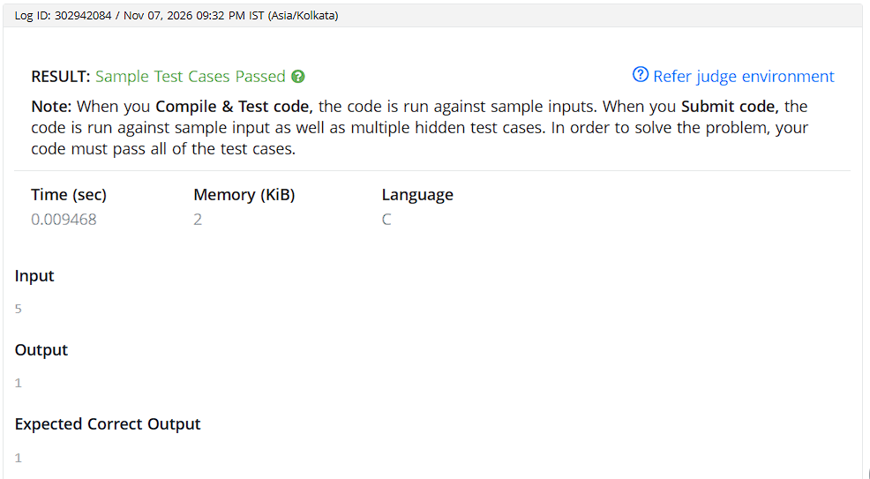

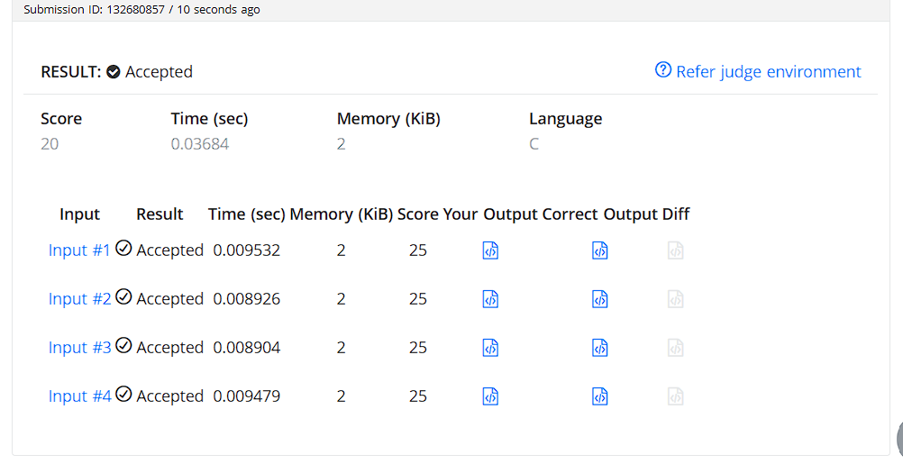

CODE:
#include <stdio.h>

int main() {
int n;
scanf("%d", &n);

int isPrime = 1;
for (int i = 2; i * i <= n; i++) {
if (n % i == 0) {
isPrime = 0;
break;
}
}

printf("%d\n", isPrime);
return 0;
}

